**VISVESVARAYA TECHNOLOGICAL UNIVERSITY**

**JNANA SANGAMA, BELGAUM - 590014**



##### MOBILE APPLICATION DEVELOPMENT LAB REPORT

##### Submitted in the partial fulfillment for Mobile Application Development Laboratory

##### Submitted By :

**NAME:- NAVEEN K N USN:-1SI19CS086**

**BATCH : B1**



#### DEPARTMENT OF COMPUTER SCIENCE AND ENGINEERING

**SIDDAGANGA INSTITUTE OF TECHNOLOGY, TUMKUR-572103**

**(An Autonomous Institute, Affiliated to Visvesvaraya Technological University, Belgaum, Recognized by AICTE and Accredited by NBA, New Delhi)**

**2021-2022**

**1)Create an application to design a Visiting Card. The Visiting card should have a company logo at the top right corner. The company name should be displayed in Capital letters, aligned to the center. Information like the name of the employee, job title, phone number, address, email, fax and the website address is to be displayed. Insert a horizontal line between the job title and the phone number.**

activity_main.xml

<?xml version="1.0" encoding="utf-8"?>

<androidx.constraintlayout.widget.ConstraintLayout xmlns:android="http://schemas.android.com/apk/res/android"

xmlns:app="http://schemas.android.com/apk/res-auto"

xmlns:tools="http://schemas.android.com/tools"

android:layout_width="match_parent"

android:layout_height="match_parent"

tools:context=".MainActivity">

<TextView

android:id="@+id/textView" android:layout_width="267dp"

android:layout_height="127dp" android:layout_marginTop="2dp"

android:layout_marginBottom="29dp" android:text="GOOGLE"

android:textAlignment="center"

android:textSize="50dp"

app:layout_constraintBottom_toTopOf="@+id/progressBar"

app:layout_constraintEnd_toStartOf="@+id/imageView2"

app:layout_constraintStart_toStartOf="parent"

app:layout_constraintTop_toTopOf="parent" />

<ImageView

android:id="@+id/imageView2"

android:layout_width="143dp"

android:layout_height="133dp"

android:layout_marginEnd="1dp"

android:layout_marginBottom="25dp"

app:layout_constraintBottom_toTopOf="@+id/progressBar"

app:layout_constraintEnd_toEndOf="parent"

app:layout_constraintStart_toEndOf="@+id/textView"

app:layout_constraintTop_toTopOf="parent"

app:srcCompat="@drawable/google" />

<ProgressBar

android:id="@+id/progressBar"

style="?android:attr/progressBarStyleHorizontal"

android:layout_width="404dp"

android:layout_height="20dp"

android:layout_marginEnd="7dp"

app:layout_constraintBottom_toBottomOf="parent"

app:layout_constraintEnd_toEndOf="parent"

app:layout_constraintStart_toStartOf="parent"

app:layout_constraintTop_toTopOf="parent"

app:layout_constraintVertical_bias="0.222" />

<TextView

android:id="@+id/textView2"

android:layout_width="408dp"

android:layout_height="67dp"

android:layout_marginStart="2dp"

android:layout_marginTop="19dp"

android:layout_marginEnd="1dp"

android:text="Name : NAVEEN K N"

android:textAlignment="center"

android:textSize="34sp"

app:layout_constraintBottom_toTopOf="@+id/textView3"

app:layout_constraintEnd_toEndOf="parent"

app:layout_constraintStart_toStartOf="parent"

app:layout_constraintTop_toBottomOf="@+id/progressBar" />

<TextView

android:id="@+id/textView3"

android:layout_width="410dp"

android:layout_height="96dp"

android:layout_marginEnd="1dp"

android:layout_marginBottom="371dp"

android:text="Job Title : Software Developer"

android:textAlignment="center"

android:textSize="34sp"

app:layout_constraintBottom_toBottomOf="parent"

app:layout_constraintEnd_toEndOf="parent"

app:layout_constraintStart_toStartOf="parent"

app:layout_constraintTop_toBottomOf="@+id/textView2" />

<TextView

android:id="@+id/textView5" android:layout_width="412dp"

android:layout_height="94dp" android:layout_marginTop="1dp"

android:layout_marginBottom="2dp" android:text="Address : Kyathsandra ,Tumkur"

android:textAlignment="center"

android:textSize="34sp"

app:layout_constraintBottom_toTopOf="@+id/textView7"

app:layout_constraintEnd_toEndOf="parent"

app:layout_constraintStart_toStartOf="parent"

app:layout_constraintTop_toBottomOf="@+id/textView6" />

<TextView

android:id="@+id/textView6"

android:layout_width="398dp"

android:layout_height="74dp"

android:layout_marginEnd="1dp"

android:text="Ph No : 8970664021"

android:textAlignment="center"

android:textSize="34dp"

app:layout_constraintBottom_toTopOf="@+id/textView5"

app:layout_constraintEnd_toEndOf="parent"

app:layout_constraintStart_toStartOf="parent"

app:layout_constraintTop_toBottomOf="@+id/textView3" />

<TextView

android:id="@+id/textView7"

android:layout_width="408dp"

android:layout_height="91dp"

android:layout_marginTop="2dp"

android:layout_marginEnd="3dp"

android:text="Email : naveen021@gmail.com"

android:textAlignment="center"

android:textSize="34dp"

app:layout_constraintBottom_toTopOf="@+id/textView8"

app:layout_constraintEnd_toEndOf="parent"

app:layout_constraintStart_toStartOf="parent"

app:layout_constraintTop_toBottomOf="@+id/textView5" />

<TextView

android:id="@+id/textView8"

android:layout_width="412dp"

android:layout_height="81dp"

android:layout_marginTop="1dp"

android:layout_marginBottom="24dp"

android:text="Website: www.shketchiwrie.com"

android:textAlignment="center"

android:textSize="34dp"

app:layout_constraintBottom_toBottomOf="parent"

app:layout_constraintEnd_toEndOf="parent"

app:layout_constraintStart_toStartOf="parent"

app:layout_constraintTop_toBottomOf="@+id/textView7" />

</androidx.constraintlayout.widget.ConstraintLayout>

MainActivity.java

package com.example.visiting_card_roshan;

import androidx.appcompat.app.AppCompatActivity;

import android.os.Bundle;

public class MainActivity extends AppCompatActivity {

@Override

protected void onCreate(Bundle savedInstanceState) {

super.onCreate(savedInstanceState);

setContentView(R.layout.activity_main);

}

}

**OUTPUT:**

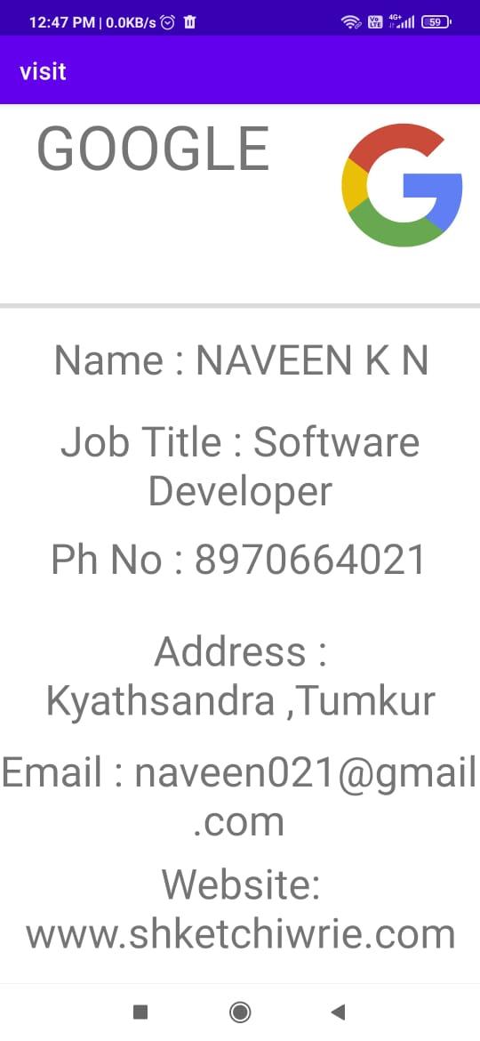

**2)Develop an Android application using controls like Button, Text View, Edit Text for designing a calculator having basic functionality like Addition, Subtraction, Multiplication and Division.**

activity_main.xml

<?xml version="1.0" encoding="utf-8"?>

<layout

xmlns:android="http://schemas.android.com/apk/res/android"

xmlns:app="http://schemas.android.com/apk/res-auto"

xmlns:tools="http://schemas.android.com/tools">

<RelativeLayout

android:layout_width="match_parent"

android:layout_height="match_parent"

tools:context=".MainActivity">

<TextView

android:layout_width="match_parent"

android:layout_height="61dp"

android:text="Simple Calculator"

android:textAlignment="center"

android:textColor="@color/purple_200"

android:textSize="34sp"

app:layout_constraintBottom_toBottomOf="parent"

app:layout_constraintLeft_toLeftOf="parent"

app:layout_constraintRight_toRightOf="parent"

app:layout_constraintTop_toTopOf="parent" />

<TextView

android:id="@+id/infoTextView"

android:layout_width="match_parent"

android:layout_height="62dp"

android:layout_marginStart="0dp"

android:textAlignment="center"

android:textSize="24dp"

android:layout_marginLeft="0dp"

android:layout_marginTop="60dp"

android:text="Result" />

<Button

android:id="@+id/buttonSeven"

android:layout_width="80dp"

android:layout_height="60dp"

android:text="7"

android:layout_marginLeft="25dp"

android:layout_marginTop="200dp"

/>

<Button

android:id="@+id/buttonEight"

android:layout_width="80dp"

android:layout_height="60dp"

android:text="8"

android:layout_marginLeft="115dp"

android:layout_marginTop="200dp"

/>

<Button

android:id="@+id/buttonNine"

android:layout_width="80dp"

android:layout_height="60dp"

android:text="9"

android:layout_marginLeft="205dp"

android:layout_marginTop="200dp"

/>

<Button

android:id="@+id/buttonDivide"

android:layout_width="80dp"

android:layout_height="60dp"

android:text="/"

android:layout_marginLeft="295dp"

android:layout_marginTop="200dp"

/>

<Button

android:id="@+id/buttonFour"

android:layout_width="80dp"

android:layout_height="60dp"

android:text="4"

android:layout_marginLeft="25dp"

android:layout_marginTop="280dp"

/>

<Button

android:id="@+id/buttonFive"

android:layout_width="80dp"

android:layout_height="60dp"

android:text="5"

android:layout_marginLeft="115dp"

android:layout_marginTop="280dp"

/>

<Button

android:id="@+id/buttonSix"

android:layout_width="80dp"

android:layout_height="60dp"

android:text="6"

android:layout_marginLeft="205dp"

android:layout_marginTop="280dp"

/>

<Button

android:id="@+id/buttonMul"

android:layout_width="80dp"

android:layout_height="60dp"

android:text="*"

android:layout_marginLeft="295dp"

android:layout_marginTop="280dp"

/>

<Button

android:id="@+id/buttonOne"

android:layout_width="80dp"

android:layout_height="60dp"

android:text="1"

android:layout_marginLeft="25dp"

android:layout_marginTop="360dp"

/>

<Button

android:id="@+id/buttonTwo"

android:layout_width="80dp"

android:layout_height="60dp"

android:text="2"

android:layout_marginLeft="115dp"

android:layout_marginTop="360dp"

/>

<Button

android:id="@+id/buttonThree"

android:layout_width="80dp"

android:layout_height="60dp"

android:text="3"

android:layout_marginLeft="205dp"

android:layout_marginTop="360dp"

/>

<Button

android:id="@+id/buttonSubt"

android:layout_width="80dp"

android:layout_height="60dp"

android:text="-"

android:layout_marginLeft="295dp"

android:layout_marginTop="360dp"

/>

<Button

android:id="@+id/buttonDot"

android:layout_width="80dp"

android:layout_height="60dp"

android:text="."

android:layout_marginLeft="25dp"

android:layout_marginTop="440dp"

/>

<Button

android:id="@+id/buttonZero"

android:layout_width="80dp"

android:layout_height="60dp"

android:text="0"

android:layout_marginLeft="115dp"

android:layout_marginTop="440dp"

/>

<Button

android:id="@+id/buttonEqual"

android:layout_width="80dp"

android:layout_height="60dp"

android:text="="

android:layout_marginLeft="205dp"

android:layout_marginTop="440dp"

/>

<Button

android:id="@+id/buttonAdd"

android:layout_width="80dp"

android:layout_height="60dp"

android:text="+"

android:layout_marginLeft="295dp"

android:layout_marginTop="440dp"

/>

<Button

android:id="@+id/buttonClear"

android:layout_width="80dp"

android:layout_height="60dp"

android:text="C"

android:layout_marginLeft="295dp"

android:layout_marginTop="520dp"

/>

<EditText

android:id="@+id/editText"

android:layout_width="match_parent"

android:layout_height="56dp"

android:layout_marginTop="123dp"

android:ems="10"

android:textAlignment="center"

android:textSize="20dp"

android:inputType="textPersonName"

android:text="" />

</RelativeLayout>

</layout>

MainActivity.java

package com.example.visitingcard;

import androidx.databinding.DataBindingUtil;

import android.os.Bundle;

import androidx.appcompat.app.AppCompatActivity;

import android.view.View;

import java.text.DecimalFormat;

import android.os.Bundle;

public class MainActivity extends AppCompatActivity {

private com.example.visitingcard.databinding.ActivityMainBinding binding;

private static final char ADDITION = '+';

private static final char SUBTRACTION = '-';

private static final char MULTIPLICATION = '*';

private static final char DIVISION = '/';

private char CURRENT_ACTION;

private double valueOne = Double.NaN;

private double valueTwo;

private DecimalFormat decimalFormat;

@Override

protected void onCreate(Bundle savedInstanceState) {

super.onCreate(savedInstanceState);

decimalFormat = new DecimalFormat("#.##########");

binding = DataBindingUtil.setContentView(this, R.layout.activity_main);

binding.buttonDot.setOnClickListener(new View.OnClickListener() {

@Override

public void onClick(View view) {

binding.editText.setText(binding.editText.getText() + ".");

}

});

binding.buttonZero.setOnClickListener(new View.OnClickListener() {

@Override

public void onClick(View view) {

binding.editText.setText(binding.editText.getText() + "0");

}

});

binding.buttonOne.setOnClickListener(new View.OnClickListener() {

@Override

public void onClick(View view) {

binding.editText.setText(binding.editText.getText() + "1");

}

});

binding.buttonTwo.setOnClickListener(new View.OnClickListener() {

@Override

public void onClick(View view) {

binding.editText.setText(binding.editText.getText() + "2");

}

});

binding.buttonThree.setOnClickListener(new View.OnClickListener() {

@Override

public void onClick(View view) {

binding.editText.setText(binding.editText.getText() + "3");

}

});

binding.buttonFour.setOnClickListener(new View.OnClickListener() {

@Override

public void onClick(View view) {

binding.editText.setText(binding.editText.getText() + "4");

}

});

binding.buttonFive.setOnClickListener(new View.OnClickListener() {

@Override

public void onClick(View view) {

binding.editText.setText(binding.editText.getText() + "5");

}

});

binding.buttonSix.setOnClickListener(new View.OnClickListener() {

@Override

public void onClick(View view) {

binding.editText.setText(binding.editText.getText() + "6");

}

});

binding.buttonSeven.setOnClickListener(new View.OnClickListener() {

@Override

public void onClick(View view) {

binding.editText.setText(binding.editText.getText() + "7");

}

});

binding.buttonEight.setOnClickListener(new View.OnClickListener() {

@Override

public void onClick(View view) {

binding.editText.setText(binding.editText.getText() + "8");

}

});

binding.buttonNine.setOnClickListener(new View.OnClickListener() {

@Override

public void onClick(View view) {

binding.editText.setText(binding.editText.getText() + "9");

}

});

binding.buttonAdd.setOnClickListener(new View.OnClickListener() {

@Override

public void onClick(View view) {

computeCalculation();

CURRENT_ACTION = ADDITION;

binding.infoTextView.setText(decimalFormat.format(valueOne) + "+");

binding.editText.setText(null);

}

});

binding.buttonSubt.setOnClickListener(new View.OnClickListener() {

@Override

public void onClick(View view) {

computeCalculation();

CURRENT_ACTION = SUBTRACTION;

binding.infoTextView.setText(decimalFormat.format(valueOne) + "-");

binding.editText.setText(null);

}

});

binding.buttonMul.setOnClickListener(new View.OnClickListener() {

@Override

public void onClick(View view) {

computeCalculation();

CURRENT_ACTION = MULTIPLICATION;

binding.infoTextView.setText(decimalFormat.format(valueOne) + "*");

binding.editText.setText(null);

}

});

binding.buttonDivide.setOnClickListener(new View.OnClickListener() {

@Override

public void onClick(View view) {

computeCalculation();

CURRENT_ACTION = DIVISION;

binding.infoTextView.setText(decimalFormat.format(valueOne) + "/");

binding.editText.setText(null);

}

});

binding.buttonEqual.setOnClickListener(new View.OnClickListener() {

@Override

public void onClick(View view) {

computeCalculation();

binding.infoTextView.setText(binding.infoTextView.getText().toString() + decimalFormat.format(valueTwo) + " = " + decimalFormat.format(valueOne));

valueOne = Double.NaN;

CURRENT_ACTION = '0'"; } });

binding.buttonClear.setOnClickListener(new View.OnClickListener() {

@Override

public void onClick(View view) {

if(binding.editText.getText().length() > 0) {

CharSequence currentText = binding.editText.getText();

binding.editText.setText(currentText.subSequence(0, currentText.length()-1));

}

else {

valueOne = Double.NaN;

valueTwo = Double.NaN;

binding.editText.setText("");

binding.infoTextView.setText(""); } } }); }

private void computeCalculation() {

if(!Double.isNaN(valueOne)) {

valueTwo = Double.parseDouble(binding.editText.getText().toString());

binding.editText.setText(null);

if(CURRENT_ACTION == ADDITION)

valueOne = this.valueOne + valueTwo;

else if(CURRENT_ACTION == SUBTRACTION)

valueOne = this.valueOne - valueTwo;

else if(CURRENT_ACTION == MULTIPLICATION)

valueOne = this.valueOne * valueTwo;

else if(CURRENT_ACTION == DIVISION)

valueOne = this.valueOne / valueTwo; }

else {

try {

valueOne = Double.parseDouble(binding.editText.getText().toString()); }

catch (Exception e){} }

}

}

**Output:**

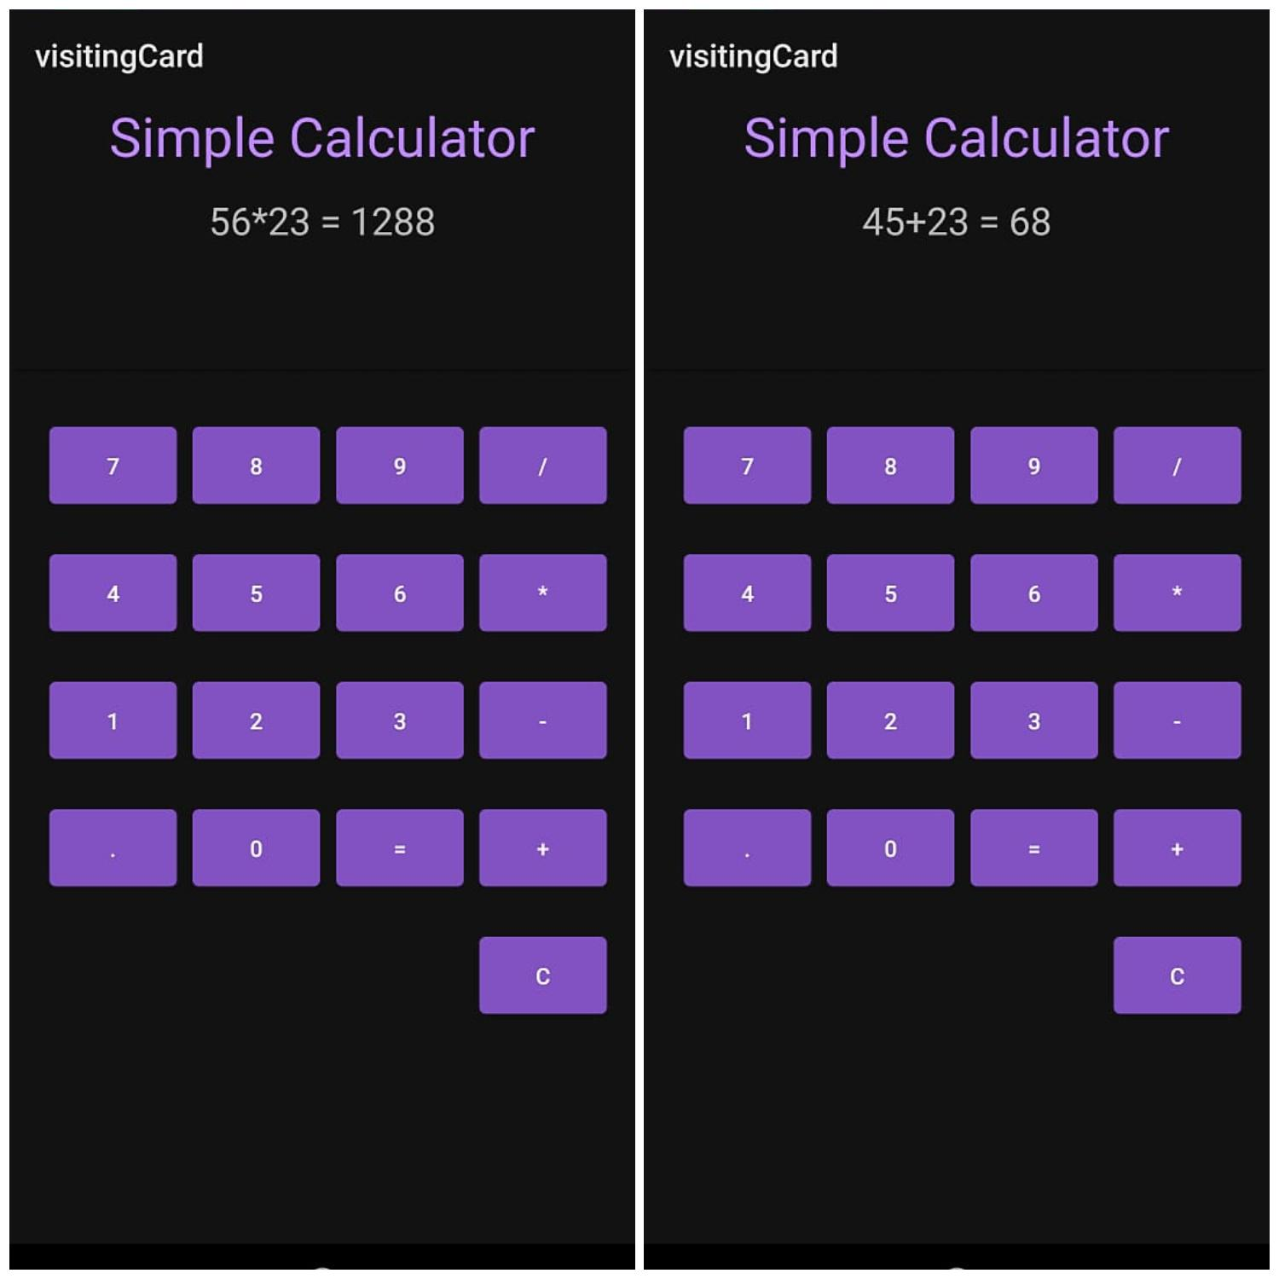

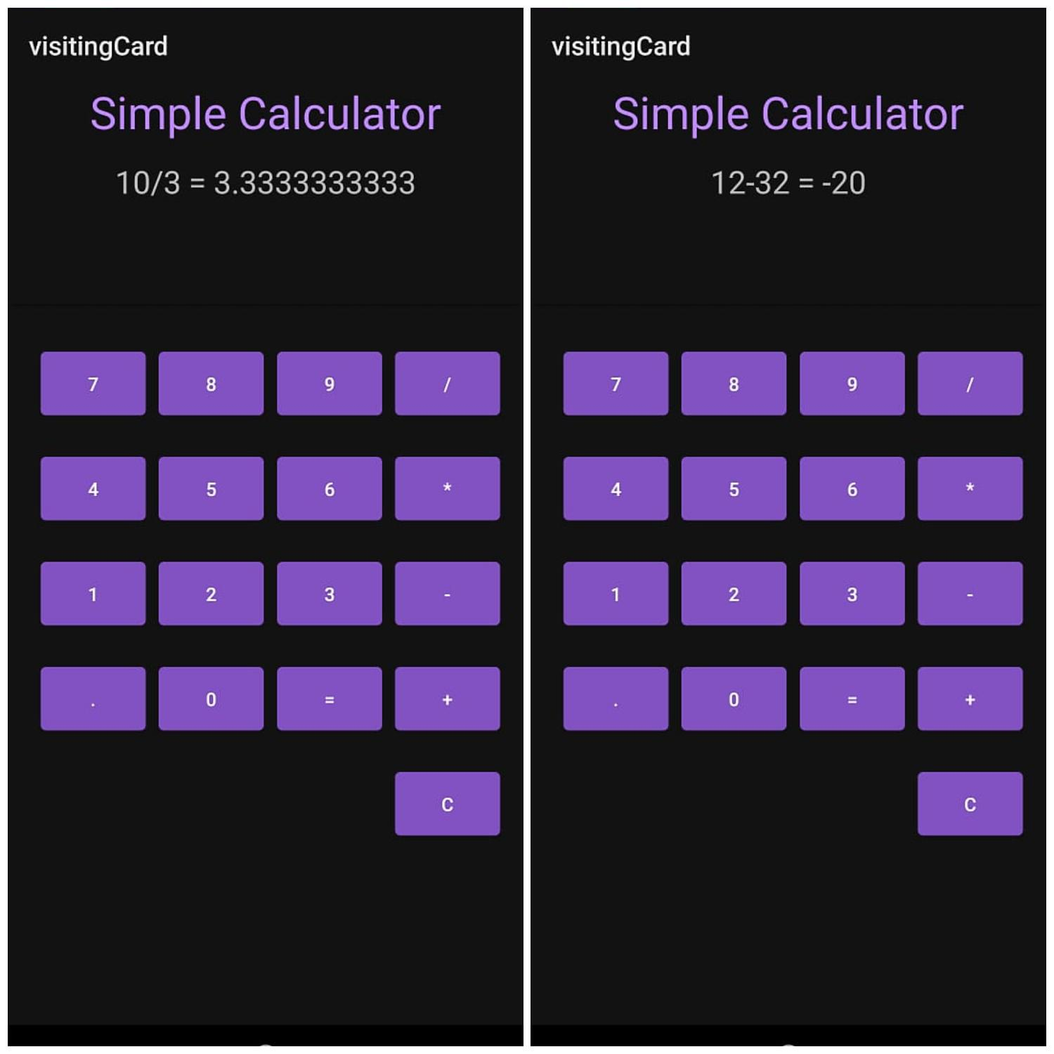

##### Create a SIGN Up activity with Username and Password. Validation of password should

##### happen based on the following rules:

##### Password should contain uppercase and lower case letters.

##### Password should contain letters and numbers.

##### Password should contain special characters.

##### Minimum length of the password (the default value is8).

##### On successful SIGN UP proceed to the next Login activity. Here the user should SIGN

##### IN using the Username and Password created during signup activity. If the Username and

##### Password are matched then navigate to the next activity which displays a message saying

##### “Successful Login” or else display a toast message saying “Login Failed”. The user is

##### given only two attempts and after that display a toast message saying “Failed Login

##### Attempts” and disable the SIGN IN button. Use Bundle to transfer information from one

##### activity to another.

**SignUp**:

**AndroidManifest.xml:**

<?xml version="1.0" encoding="utf-8"?>

<manifest xmlns:android="http://schemas.android.com/apk/res/android"

package="com.example.signuplogin">

<application

android:allowBackup="true"

android:icon="@mipmap/ic_launcher"

android:label="REGISTER"

android:roundIcon="@mipmap/ic_launcher_round"

android:supportsRtl="true"

android:theme="@style/AppTheme">

<activity android:name=".LoginActivity"></activity>

<activity android:name=".MainActivity"

android:exported="true">

<intent-filter>

<action android:name="android.intent.action.MAIN" />

<category android:name="android.intent.category.LAUNCHER" />

</intent-filter>

</activity>

</application>

</manifest>

**Activity main.xml:**

<?xml version="1.0" encoding="utf-8"?>

<LinearLayout xmlns:android="http://schemas.android.com/apk/res/android"

xmlns:app="http://schemas.android.com/apk/res-auto"

xmlns:tools="http://schemas.android.com/tools"

android:layout_width="match_parent"

android:layout_height="match_parent"

tools:context=".MainActivity"

android:orientation="vertical"

android:layout_gravity="center_horizontal"

android:background="@drawable/back2">

<TextView

android:layout_width="wrap_content"

android:layout_height="wrap_content"

android:text="SIGNUP ACTIVITY"

android:textSize="30sp"

android:textColor="#0A090A"

android:layout_marginLeft="80sp"

android:layout_marginTop="100dp"

android:textStyle="bold"

/>

<LinearLayout

android:layout_width="wrap_content"

android:layout_height="wrap_content"

android:orientation="horizontal"

android:layout_gravity="center_horizontal"

android:layout_marginTop="40dp"

>

<TextView

android:layout_width="wrap_content"

android:layout_height="wrap_content"

android:text="Username"

android:textSize="20dp"

android:textColor="#131716"

android:textStyle="bold"

android:layout_marginRight="20dp"

/>

<EditText

android:id="@+id/username"

android:layout_width="200dp"

android:layout_height="50dp"

android:textColor="#131515"

android:textStyle="bold"

tools:ignore="SpeakableTextPresentCheck" />

</LinearLayout>

<LinearLayout

android:layout_width="wrap_content"

android:layout_height="wrap_content"

android:orientation="horizontal"

android:layout_gravity="center_horizontal"

android:layout_marginTop="40dp"

>

<TextView

android:layout_width="wrap_content"

android:layout_height="wrap_content"

android:text="Password"

android:textSize="20dp"

android:textColor="#131716"

android:textStyle="bold"

android:layout_marginRight="20dp"

/>

<EditText

android:id="@+id/password"

android:layout_width="200dp"

android:layout_height="50dp"

android:textColor="#131515"

android:textStyle="bold"

tools:ignore="SpeakableTextPresentCheck" />

</LinearLayout>

<Button

android:id="@+id/signup"

android:layout_width="wrap_content"

android:layout_height="wrap_content"

android:text="SIGN UP"

android:textStyle="bold"

android:textSize="25dp"

android:textColor="#E6B9C8"

android:layout_gravity="center_horizontal"

android:layout_marginTop="30dp"

android:background="#0E0C0E"

android:padding="10dp"/>

</LinearLayout>

**Activity_Login.xml:**

<?xml version="1.0" encoding="utf-8"?>

<LinearLayout xmlns:android="http://schemas.android.com/apk/res/android"

xmlns:app="http://schemas.android.com/apk/res-auto"

xmlns:tools="http://schemas.android.com/tools"

android:layout_width="match_parent"

android:layout_height="match_parent"

tools:context=".MainActivity"

android:orientation="vertical"

android:layout_gravity="center_horizontal"

android:background="@drawable/back2"

>

<TextView

android:layout_width="wrap_content"

android:layout_height="wrap_content"

android:text="LOGIN ACTIVITY"

android:textSize="30sp"

android:textColor="#121111"

android:layout_marginLeft="80sp"

android:layout_marginTop="100dp"

android:textStyle="bold"

/>

<LinearLayout

android:layout_width="wrap_content"

android:layout_height="wrap_content"

android:orientation="horizontal"

android:layout_gravity="center_horizontal"

android:layout_marginTop="40dp"

>

<TextView

android:layout_width="wrap_content"

android:layout_height="wrap_content"

android:text="Username"

android:textSize="20dp"

android:textColor="#131716"

android:textStyle="bold"

android:layout_marginRight="20dp"

/>

<EditText

android:id="@+id/Username"

android:layout_width="200dp"

android:layout_height="50dp"

android:textColor="#131515"

android:textStyle="bold"

tools:ignore="SpeakableTextPresentCheck" />

</LinearLayout>

<LinearLayout

android:layout_width="wrap_content"

android:layout_height="wrap_content"

android:orientation="horizontal"

android:layout_gravity="center_horizontal"

android:layout_marginTop="40dp"

>

<TextView

android:layout_width="wrap_content"

android:layout_height="wrap_content"

android:text="Password"

android:textSize="20dp"

android:textColor="#131716"

android:textStyle="bold"

android:layout_marginRight="20dp"

/>

<EditText

android:id="@+id/Password"

android:layout_width="200dp"

android:layout_height="50dp"

android:textColor="#131515"

android:textStyle="bold"

tools:ignore="SpeakableTextPresentCheck" />

</LinearLayout>

<Button

android:id="@+id/signin"

android:layout_width="wrap_content"

android:layout_height="wrap_content"

android:text="SIGN IN"

android:textStyle="bold"

android:textSize="25dp"

android:textColor="#E6B9C8"

android:layout_gravity="center_horizontal"

android:layout_marginTop="30dp"

android:background="#110F11"

android:padding="10dp"/>

</LinearLayout>

**Main activity.java:**

Package com.example.signup;

Import androidx.appcompat.app.AppCompatActivity;

Import android.content.Intent;

Import android.os.Bundle;

Import android.view.View;

Import android.widget.Button;

Import android.widget.EditText;

Import android.widget.Toast;

Import java.util.regex.Matcher;

Import java.util.regex.Pattern;

Public class MainActivity extends AppCompatActivity {

@Override

Protected void onCreate(Bundle savedInstanceState) {

Super.onCreate(savedInstanceState);

setContentView(R.layout.activity_main);

Button SignUpButton = findViewById(R.id.button);

SignUpButton.setOnClickListener(new View.OnClickListener()

@Override

Public void onClick(View v)

userText=findViewById(R.id.username);

EditText passText=findViewById(R.id.password);

String SUuser=userText.getText().toString();

String SUpass=passText.getText().toString();

If (validatePass(SUpass)){

Toast.makeText(MainActivity.this, “SIGNUP SUCCESSUL”,

Toast.LENGTH_SHORT).show();

Intent intent = new Intent(MainActivity.this, Login.class

Intent.putExtra(“Username”, SUuser)

Intent.putExtra(“Password”, SUpass);

startActivity(intent)

}

Else{

Toast.makeText(MainActivity.this,”INVALID PASSWORD”,

Toast.LENGTH_SHORT ).show();

}

}

});

}

}

Private boolean validatePass(String pwd){

String regex = “^(?=.*[0-9])(?=.*[a-z])(?=.*[A-Z])(?=.*[@#$%^&-+=()])(?=\\S+$).{8,20}$”;

Pattern p = Pattern.compile(regex);

If(pwd==null){

Return false;

}

Matcher m=p.matcher(pwd);

Return m.matches();

}

}

Import java.util.regex.Pattern;

Public class MainActivity extends AppCompatActivity {

@Override

Protected void onCreate(Bundle savedInstanceState) {

Super.onCreate(savedInstanceState);

setContentView(R.layout.activity_main);

Button SignUpButton = findViewById(R.id.button);

SignUpButton.setOnClickListener(new View.OnClickListener()

@Override

Public void onClick(View v)

userText=findViewById(R.id.username);

EditText passText=findViewById(R.id.password);

String SUuser=userText.getText().toString();

String SUpass=passText.getText().toString();

If (validatePass(SUpass)){

Toast.makeText(MainActivity.this, “SIGNUP SUCCESSUL”,

Toast.LENGTH_SHORT).show();

Intent intent = new Intent(MainActivity.this, Login.class

Intent.putExtra(“Username”, SUuser)

Intent.putExtra(“Password”, SUpass);

startActivity(intent)

}

Else{

Toast.makeText(MainActivity.this,”INVALID PASSWORD”,

Toast.LENGTH_SHORT ).show();

}

}

});

**Activity_Login.java:**

package com.example.signup;

import androidx.annotation.Nullable;

import androidx.appcompat.app.AppCompatActivity;

import android.os.Bundle;

import android.view.View;

import android.widget.Button;

import android.widget.EditText;

import android.widget.Toast;

public class Login extends AppCompatActivity {

int counter=0;

@Override

protected void onCreate(@Nullable Bundle savedInstanceState) {

super.onCreate(savedInstanceState);

setContentView(R.layout.activity_login);

Button Signin = findViewById(R.id.button);

Signin.setOnClickListener(new View.OnClickListener() {

@Override

public void onClick(View v) {

Bundle bundle=getIntent().getExtras();

String Luser=bundle.getString("Username");

String Lpass=bundle.getString("Password");

EditText LIuser=findViewById(R.id.username);

EditText LIpass=findViewById(R.id.password);

String user= LIuser.getText().toString().trim();

String pass=LIpass.getText().toString().trim();

if(user.equals(Luser)&&pass.equals(Lpass))

Toast.makeText(Login.this, "LOGIN SUCCESSFUL",

Toast.LENGTH_SHORT).show();

}

else {

counter++;

if (counter>2){

Toast.makeText(Login.this,"3 WRONG ATTEMTS",

Toast.LENGTH_SHORT).show();

}

}

}

});

}

}

**OUTPUT:**

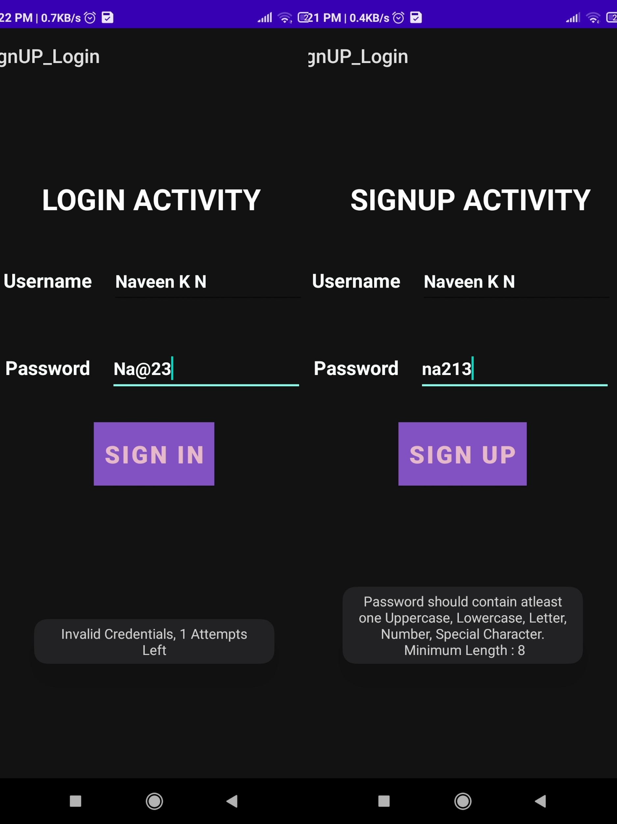

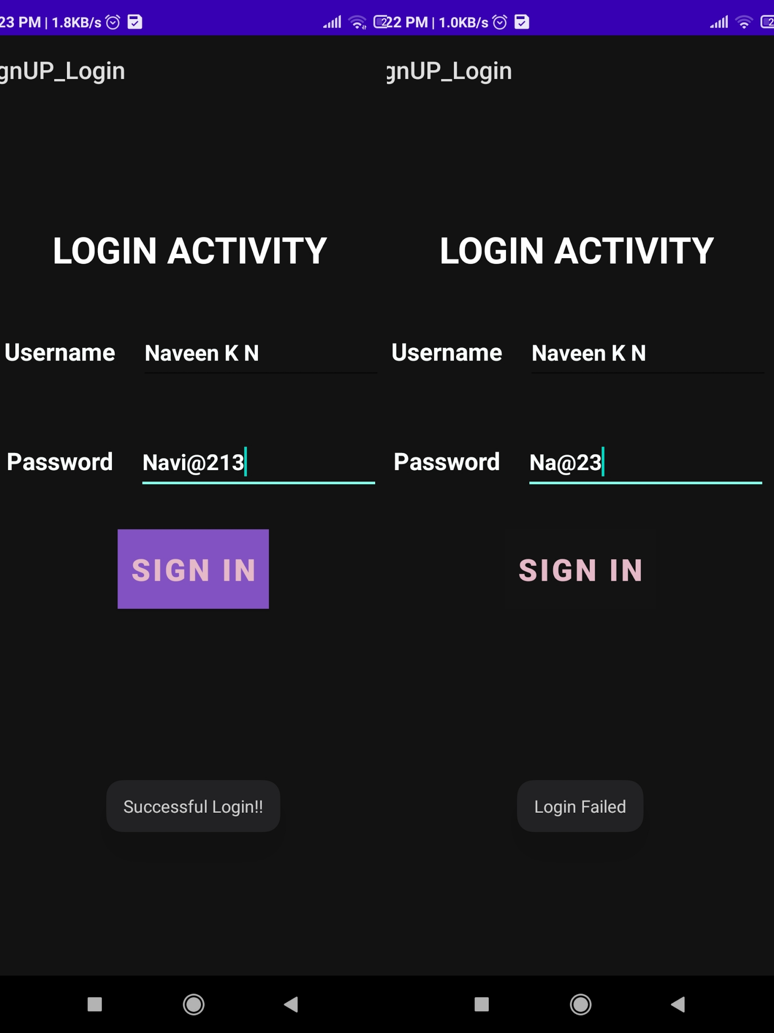

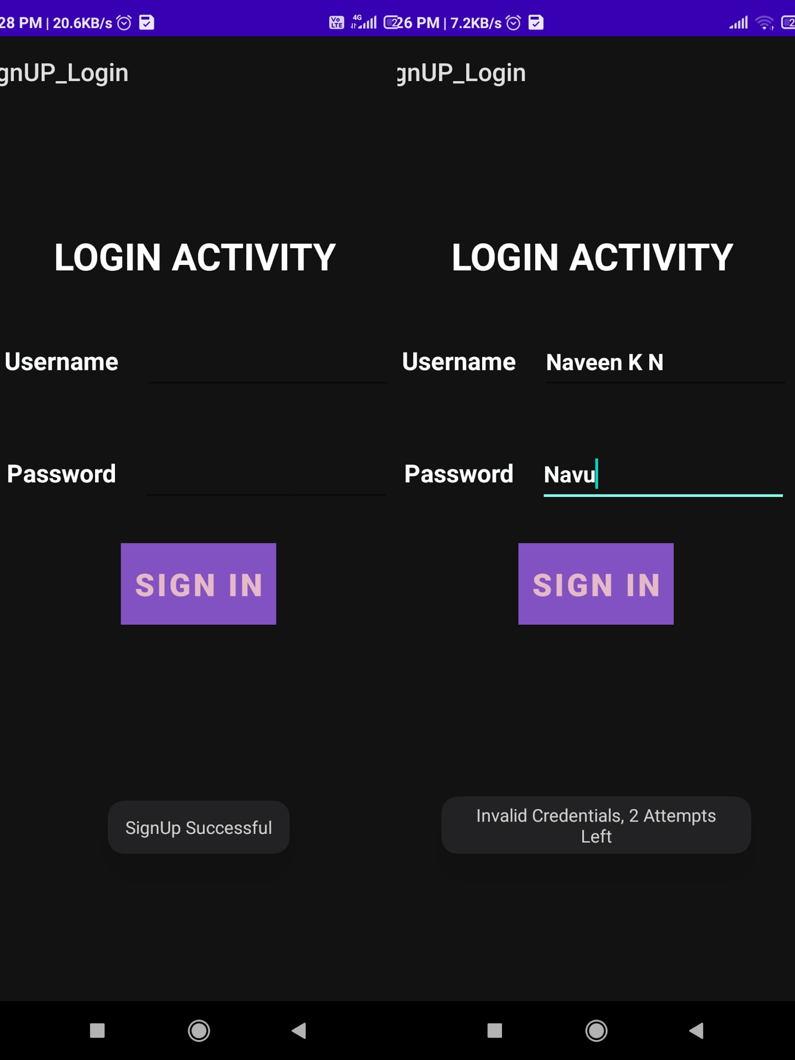

**4.Develop an application to set an image as wallpaper. On click of a button, the wallpaper**

**image should start to change randomly every 30 seconds.**

**Activity_Main.xml**

<?xml version="1.0" encoding="utf-8"?>

<RelativeLayout xmlns:android="http://schemas.android.com/apk/res/android"

xmlns:app="http://schemas.android.com/apk/res-auto"

xmlns:tools="http://schemas.android.com/tools"

android:id="@+id/background"

android:layout_width="match_parent"

android:layout_height="match_parent"

tools:context=".MainActivity">

<TextView

android:id="@+id/textView"

android:layout_width="match_parent"

android:layout_height="98dp"

android:layout_marginTop="20dp"

android:layout_marginBottom="175dp"

android:background="@color/teal_200"

android:text="CHANGING WALLPAPER APPLICATION"

android:textColor="@color/purple_700"

android:textSize="30sp"

app:layout_constraintBottom_toTopOf="@+id/wpbutton"

app:layout_constraintEnd_toEndOf="parent"

app:layout_constraintStart_toStartOf="parent"

app:layout_constraintTop_toTopOf="parent" />

<Button

android:id="@+id/wpbutton"

android:layout_width="417dp"

android:layout_height="wrap_content"

android:layout_centerHorizontal="true"

android:layout_marginStart="4dp"

android:layout_marginLeft="4dp"

android:layout_marginTop="600dp"

android:layout_marginEnd="5dp"

android:layout_marginRight="5dp"

android:text="CLICK HERE TO CHANGE WALLPAPER"

android:textSize="24dp"

app:layout_constraintEnd_toEndOf="parent"

app:layout_constraintStart_toStartOf="parent"

app:layout_constraintTop_toBottomOf="@+id/textView" />

</RelativeLayout>

**Main_Activity.java**

package com.example.wallpaper_1si19cs086;

import androidx.appcompat.app.AppCompatActivity;

import androidx.core.content.ContextCompat;

import android.os.Bundle;

import android.view.View;

import android.widget.Button;

import java.util.Random;

import java.util.Timer;

import java.util.TimerTask;

public class MainActivity extends AppCompatActivity {

int[] images;

Timer time=new Timer();

TimerTask timerTask;

@Override

protected void onCreate(Bundle savedInstanceState) {

super.onCreate(savedInstanceState);

setContentView(R.layout.activity_main);

Button status=findViewById(R.id.wpbutton);

images =new int[]{R.drawable.a,R.drawable.b,R.drawable.d,R.drawable.f,R.drawable.g};

status.setOnClickListener(new View.OnClickListener(){

@Override

public void onClick(View v)

{

time.scheduleAtFixedRate(new TimerTask() {

@Override

public void run() {

View wallview=findViewById(R.id.background);

int num=images.length;

Random random=new Random();

int rnum=random.nextInt(num);

runOnUiThread(new Runnable() {

@Override

public void run() {

wallview.setBackground(ContextCompat.getDrawable(getApplicationContext(),images[rnum]));

}

});

}

},0,3000);

}

});

}

}

**OUTPUT:**

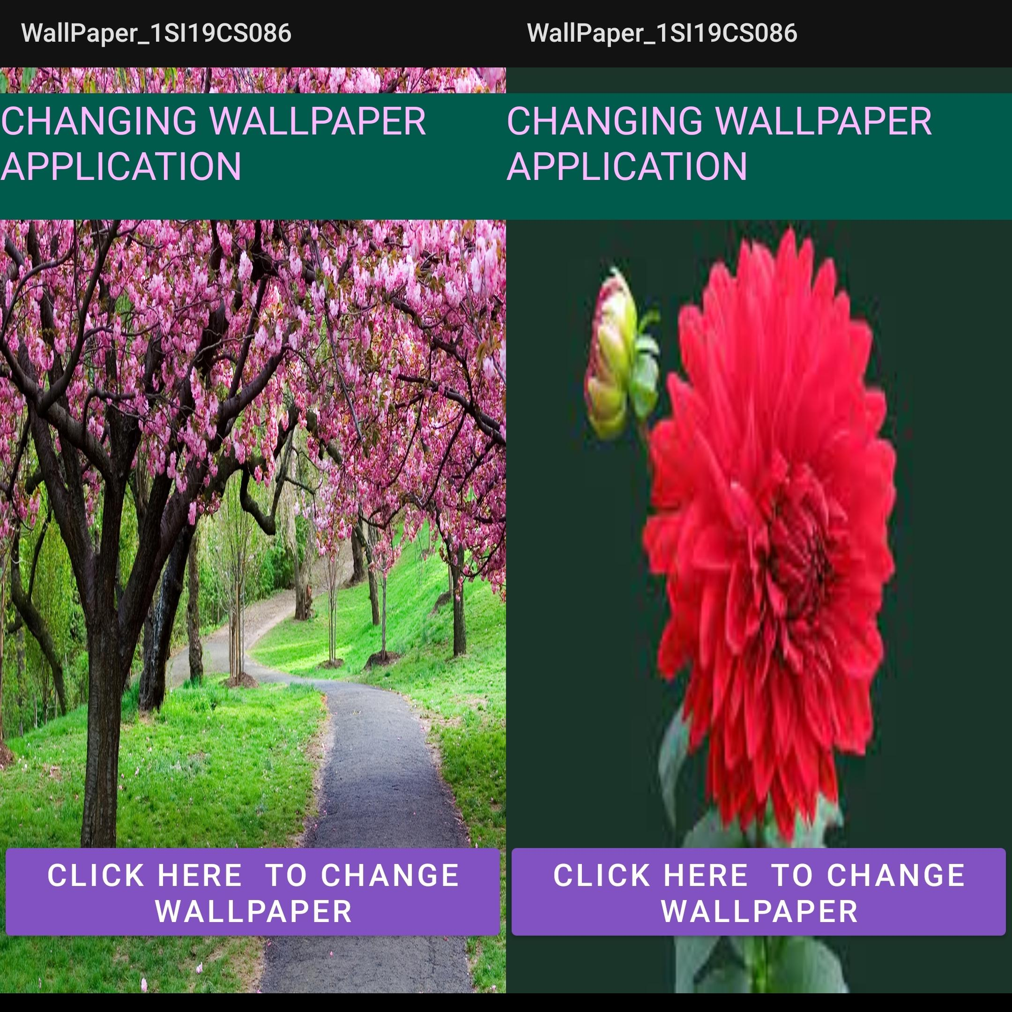

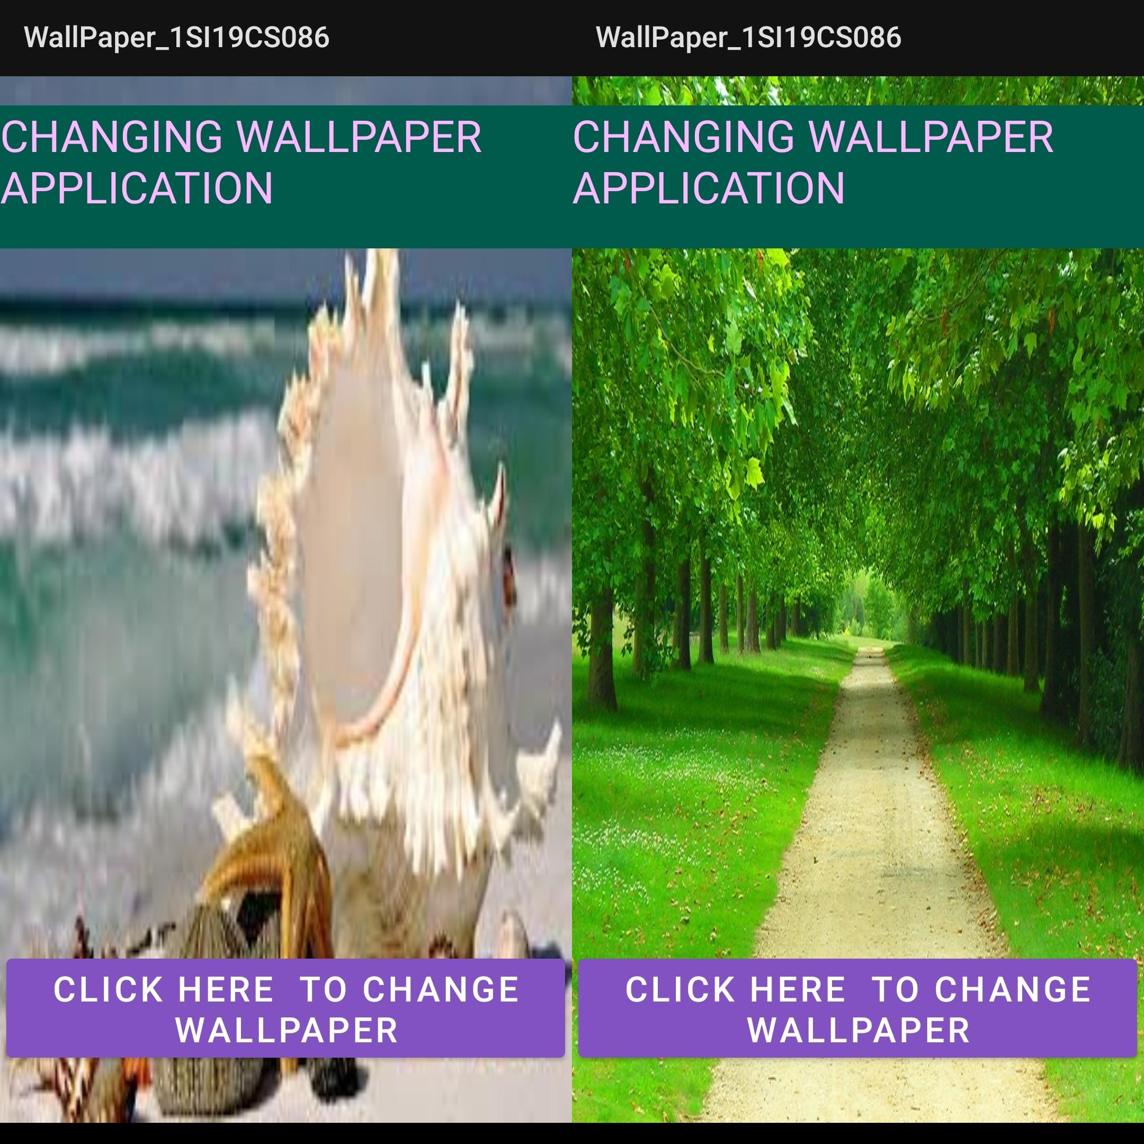

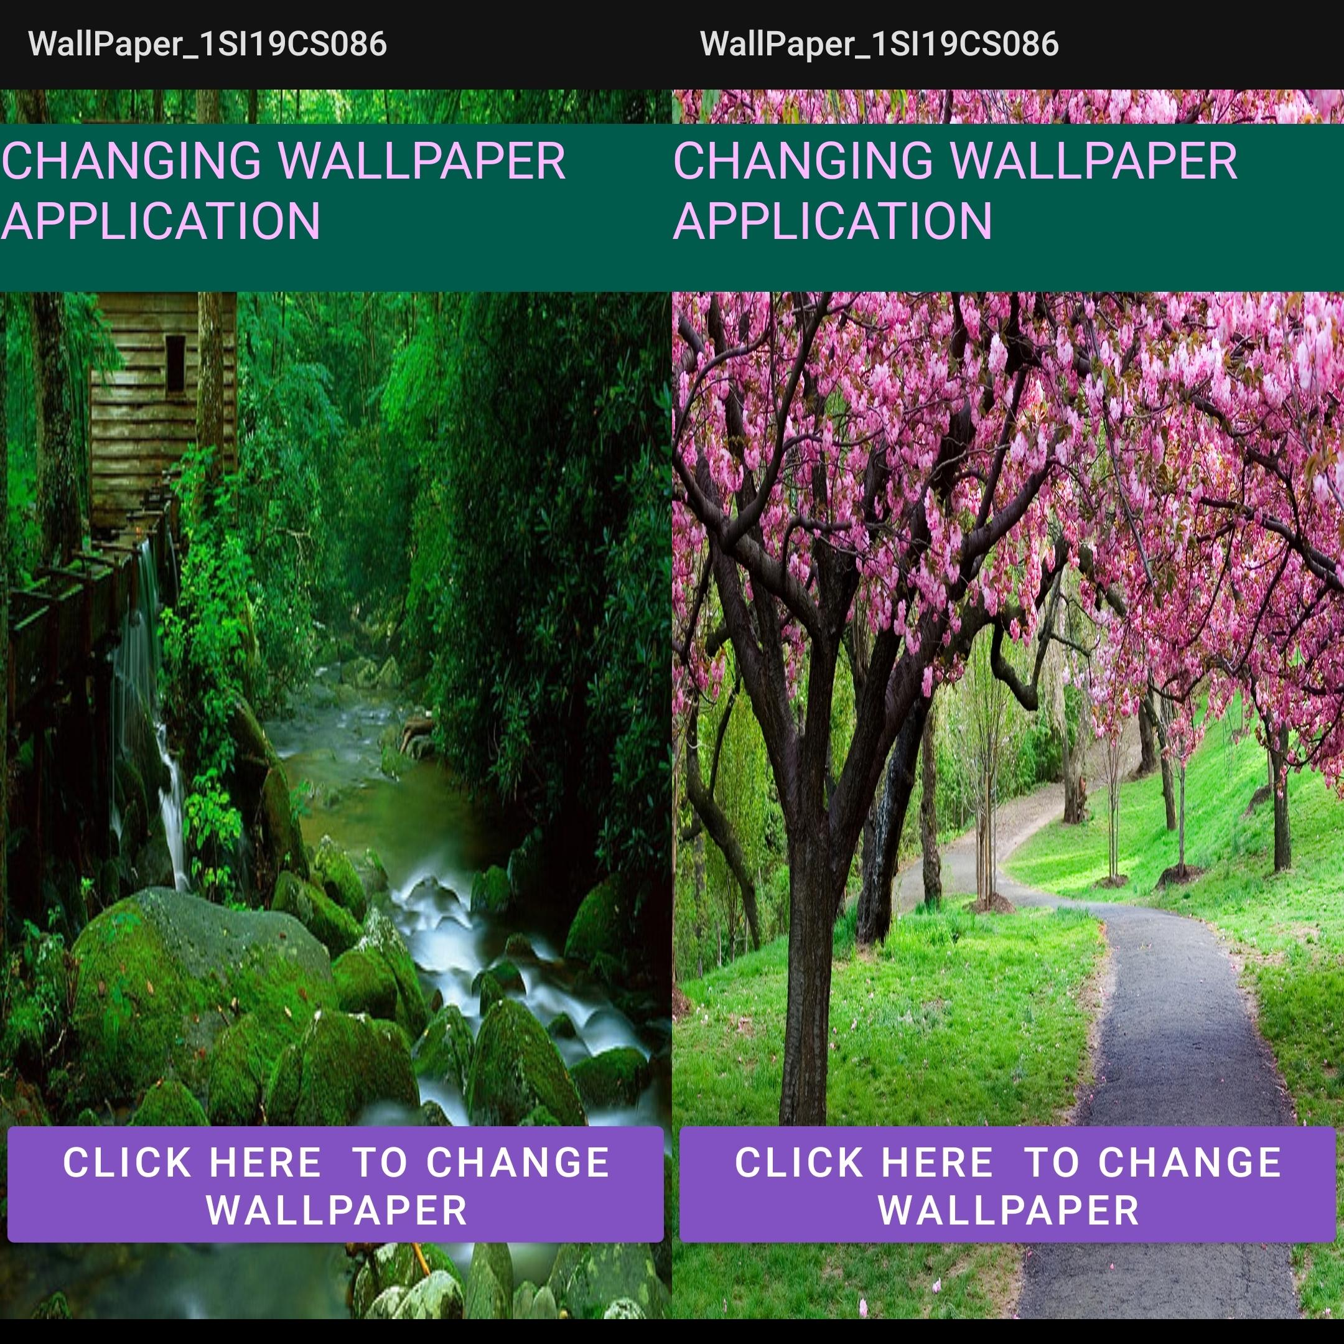

**5.Write a program to create an activity with two buttons START and STOP. On pressing of the START button, the activity must start the counter by displaying the numbers from One and the counter must keep on counting until the STOP button is pressed. Display the counter value in a Text View control.**

**Activity_main.xml:**

<?xml version="1.0" encoding="utf-8"?>

<LinearLayout xmlns:android="http://schemas.android.com/apk/res/android"

xmlns:app="http://schemas.android.com/apk/res-auto"

xmlns:tools="http://schemas.android.com/tools"

android:layout_width="match_parent"

android:layout_height="match_parent"

tools:context=".MainActivity"

android:orientation="vertical"

>

<TextView

android:id="@+id/textView"

android:layout_width="match_parent"

android:layout_height="wrap_content"

android:layout_marginTop="50dp"

android:text="COUNTER APPLICATION"

android:textColor="@color/purple_700"

android:textSize="36sp"

android:textStyle="bold"

android:background="@color/teal_200"/>

<EditText

android:id="@+id/edit1"

android:layout_width="match_parent"

android:layout_height="wrap_content"

android:layout_marginTop="50dp"

android:inputType="textPersonName"

android:text="Counter value"

android:textSize="50dp"

android:textAlignment="center"

android:layout_gravity="center"/>

<Button

android:id="@+id/start"

android:layout_width="wrap_content"

android:layout_height="wrap_content"

android:layout_marginTop="50dp"

android:layout_gravity="center"

android:textSize="30dp"

android:padding="5dp"

android:text="START" />

<Button

android:id="@+id/stop"

android:layout_width="wrap_content"

android:layout_height="wrap_content"

android:layout_marginTop="50dp"

android:layout_gravity="center"

android:textSize="30dp"

android:padding="5dp"

android:text=" STOP "

/>

</LinearLayout>

**MainActivity.java:**

package com.example.a1si19cs086_counter;

import androidx.appcompat.app.AppCompatActivity;

import android.os.Bundle;

import android.preference.EditTextPreference;

import android.view.View;

import android.view.View.OnClickListener;

import android.widget.Button;

import android.widget.EditText;

public class MainActivity extends AppCompatActivity {

int count=0;

@Override

protected void onCreate(Bundle savedInstanceState) {

super.onCreate(savedInstanceState);

setContentView(R.layout.activity_main);

EditText countValue=findViewById(R.id.edit1);

Button start=findViewById(R.id.start);

Button stop=findViewById(R.id.stop);

start.setOnClickListener(new View.OnClickListener(){

@Override

public void onClick(View view) {

new Thread(new Runnable(){

@Override

public void run() {

while (!stop.isPressed()) {

try {

Thread.sleep(500);

} catch (InterruptedException e) {

e.printStackTrace();

return;

}

countValue.post(new Runnable() {

@Override

public void run() {

countValue.setText(""+count);

count++;

}

});

}

}

}).start();

}

});

stop.setOnClickListener(new View.OnClickListener(){

@Override

public void onClick(View view)

{

count=0;

try{

Thread.sleep(500);

}

catch (InterruptedException e){

e.printStackTrace();

}

countValue.setText(""+count);

}

});

}

}

**OUTPUT:**

